# Project Journal – 3D Graphics and Animation

## 24/09/2024 – 16:50 - Meeting

* Talked about general ideas
* Art style, low poly/cartoony, could make geometry intense
* If file is too big we could lose marks
* Decided on low poly/cartoony art-style, cell shading(?)
* How technical do we want to make objects for the fly through?
  + Make objects in blender
  + Import into unreal
  + Do animations there, not necessarily in blender
  + Lighting/settings in unreal mostly for fly-through
* Need Group github, follow specific structure
* Make an actual scene, composition.
* Make the room, set up the lighting. Different parts of the room have different objects, direct a camera to each object separately(?)
* Depth of field for background objects, keep them low poly, can be out of focus
* Github has been created

Final Decisions

* Common style
  + Low poly/cartoony
* One common background scene
  + Dorm Room
* Common Object theme
  + Student Dorm Room
* What kind of Objects – NOT COMPLETELY FINALISED
  + Kumi – Mushroom Lamp
  + Owen – Guitar(?)
  + Iona – Snake Tank(?)
* Mood Board to establish our artstyle

## 27/09/2024 – Guitar Model Beginning and Progress

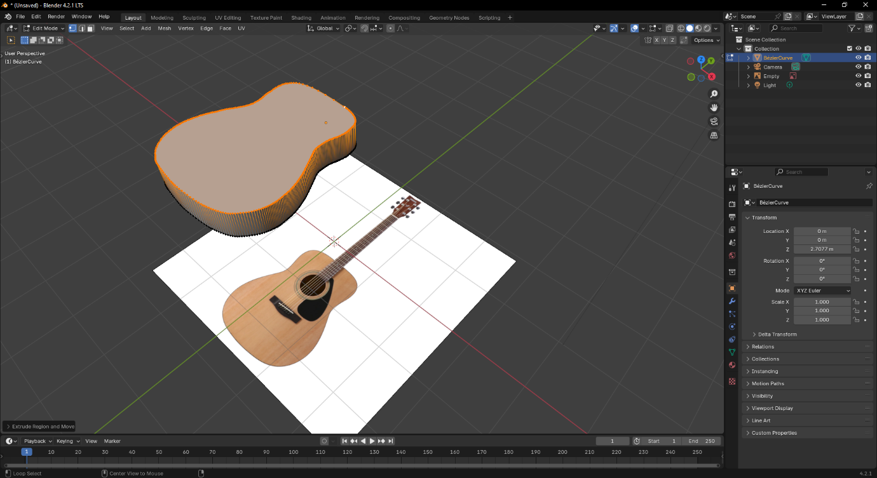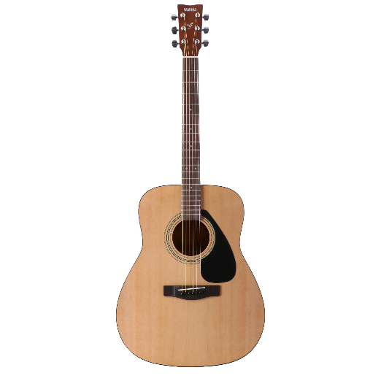I found a reference image online of the guitar I own so that I could get the basic shape of it down in blender. I used Belier curves to get the shape of the body, then converted this to a mesh and extruded.

This had a problem though, there were a LOT of vertices, so I used a limited dissolve to reduce the poly count as our group was going for a low-poly cartoony style.

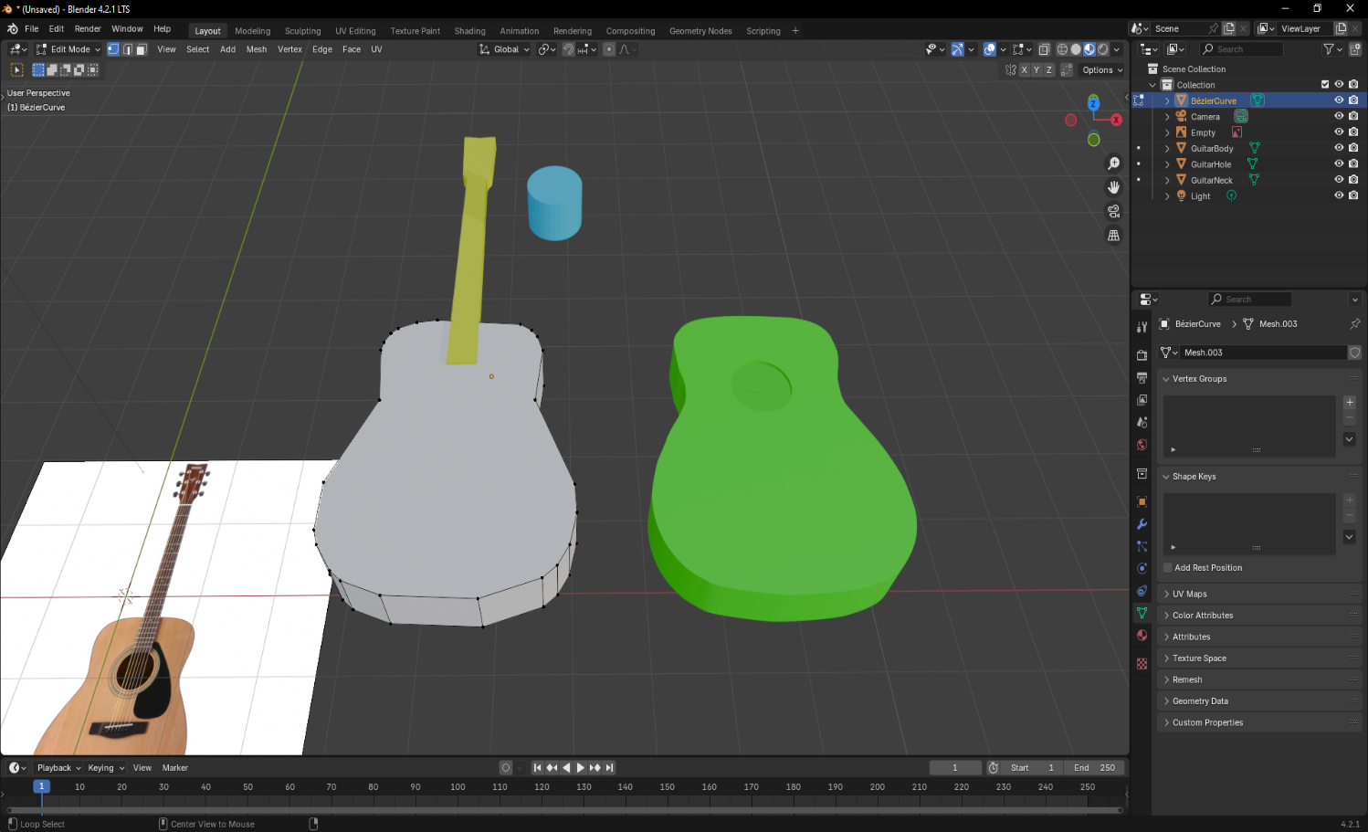Following this I worked on the other main parts of the guitar:

* The Neck
* Headstock
* Tuning Pegs
* Pick Guard
* Sound hole
* Strings
* Bridge

I colour coded these during this process for visual clarity while modelling.

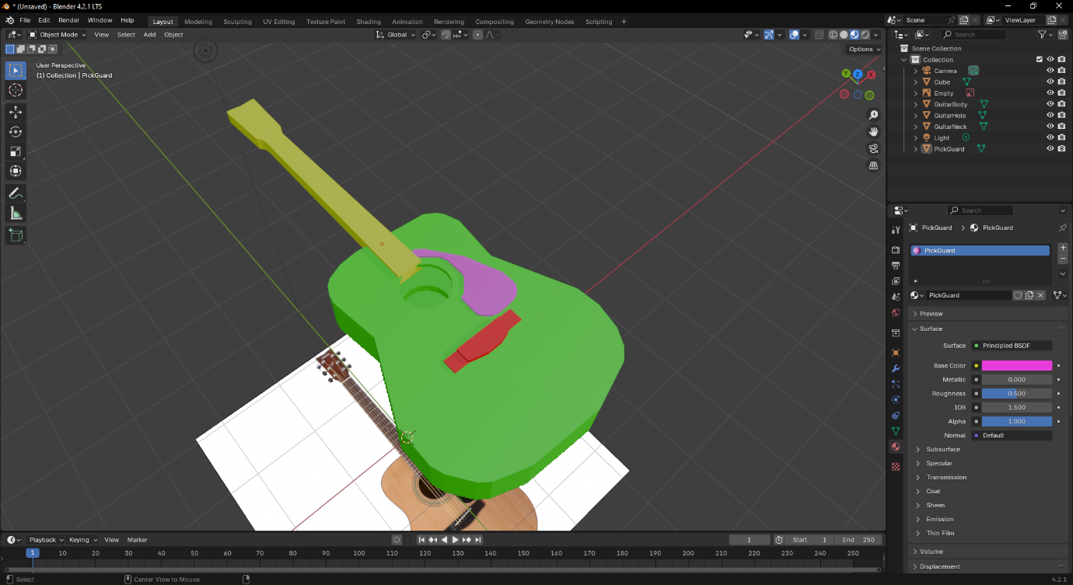Here is the model part-way through and it is really starting to take shape.

The pick-guard was made using belier curves in a similar fashion to the body.

The neck was a plane that was made to shape using the reference and then extruded, the same goes for the bridge.

## 28/09/2024 – Finishing up the model and Texturing

Yesterday I got about half-way through making the model, today was for adding in the additional pieces such as the strings and tuning pegs, along with texturing the model.

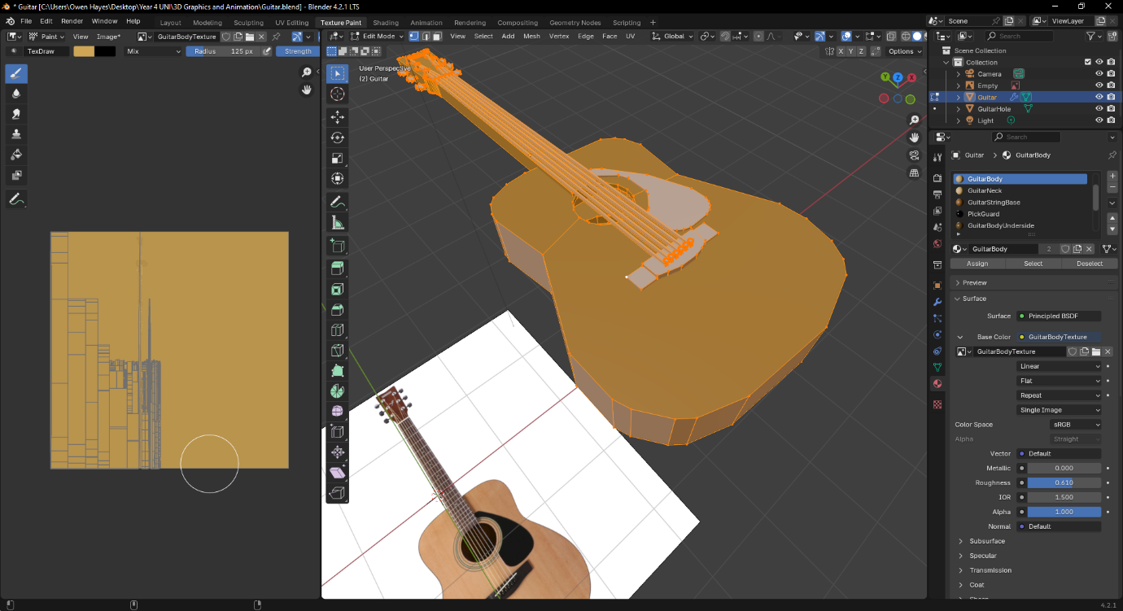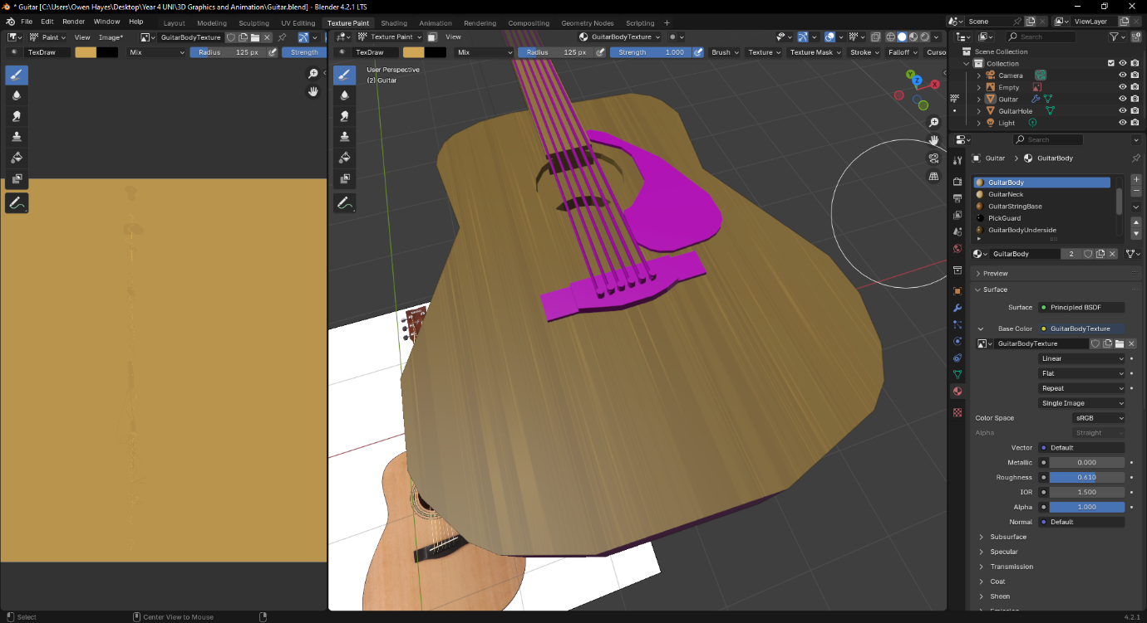This is an early texture for the body, although after communicating with my group we agreed that it was not quite the cartoony style we were aiming for.

I had to learn how to UV map, I didn’t fully manage to figure it out but I was able to get the art-style I was looking for with what I managed to do.

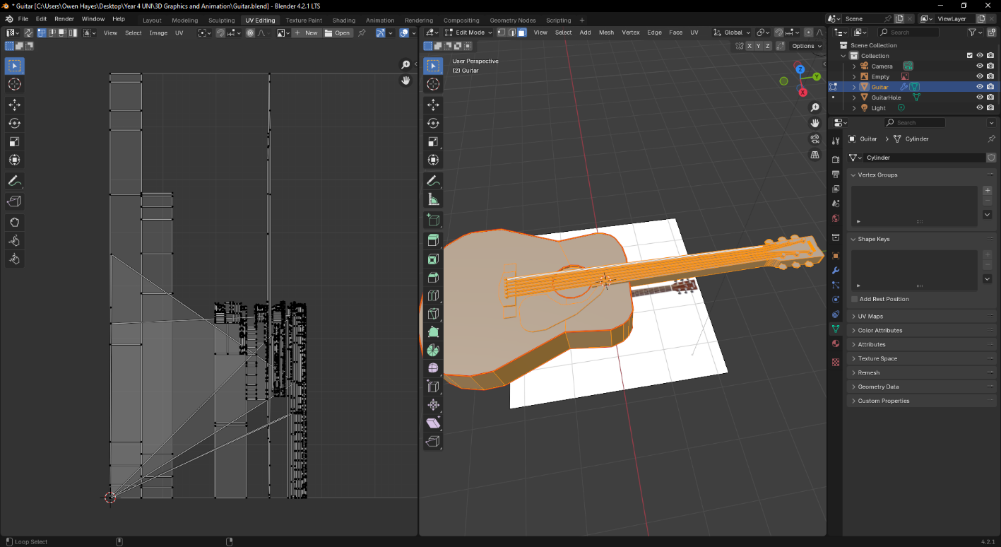

I eventually decided to manually move the points on the UV map close to the shape of the object so that I could paint it much easier than with the current UV map.

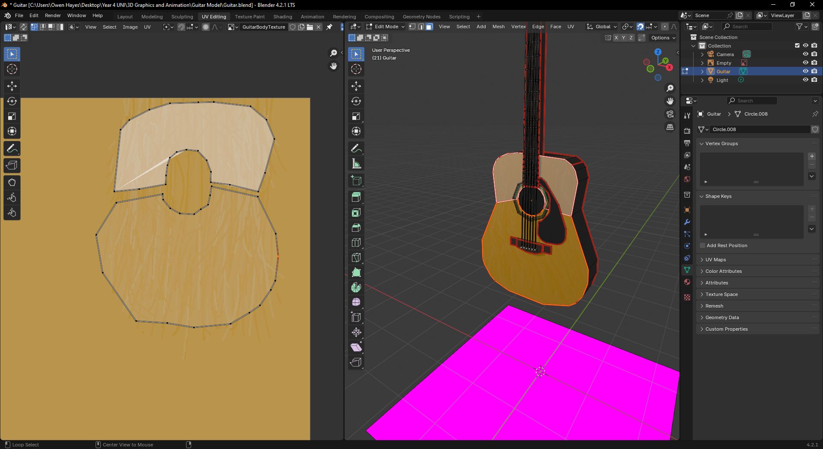

This is the new UV map that I had made by moving the points around, this did the job but I will learn and improve my UV mapping so that I can do it the proper way in future.

From here it was mostly texturing or assigning materials to the other parts of the guitar which wasn’t too bad.

## 29/09/2024 – Final Touches and Photos of model

There were only some final tweaks needed to be made to the model at this stage:

* Joining the different segments together
* Giving the metallic parts an appropriate amount of shine
* Adding some minor details to the body

The segments were easily joined together to make the guitar one complete model, which made it easier to orientate when taking the photos later on.

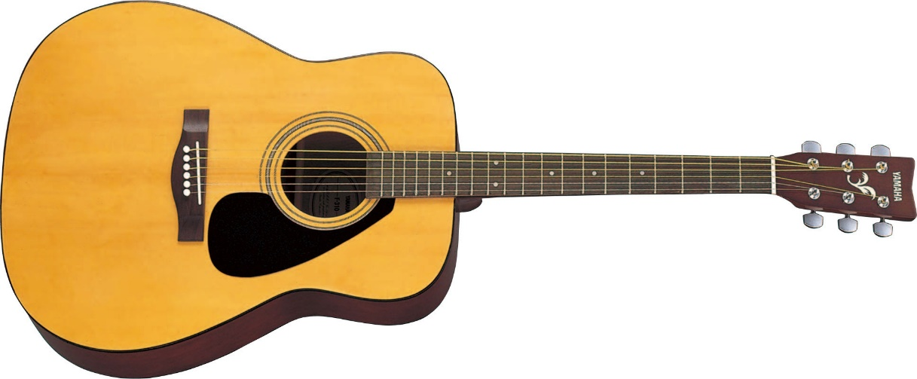One detail I decided to add to the model was these coloured rings around the sound hole that I had initially overlooked

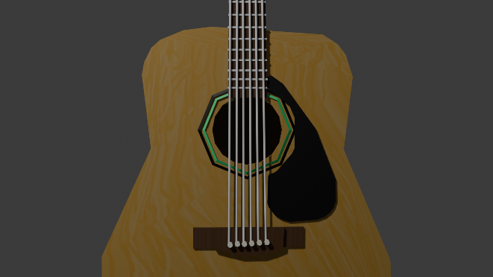

Reference Image

My Model

I felt that these added a nice amount of detail to the body rather than it just staying looking plain, additionally I added the “YAMAHA” text to the top of the headstock (shown in final image)

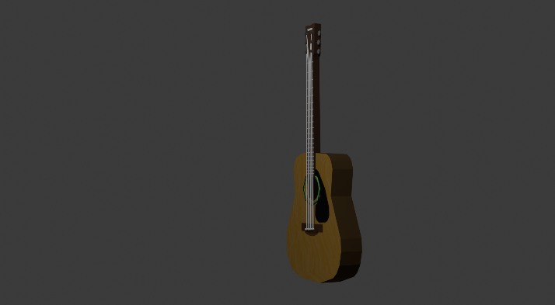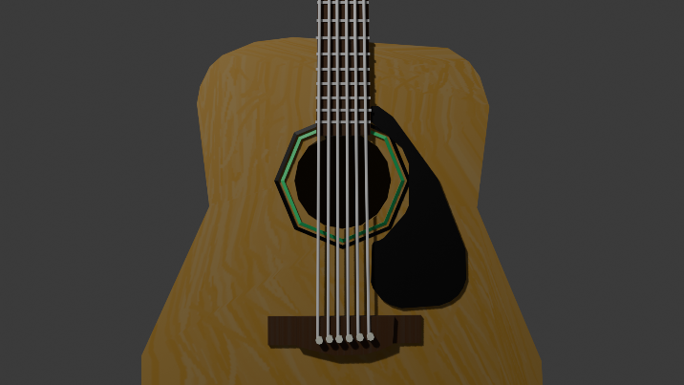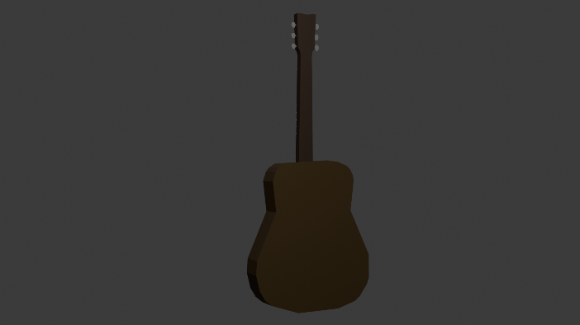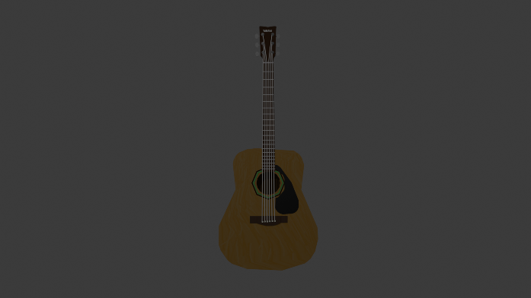After this, I was finished with the model so I rendered some images of it.

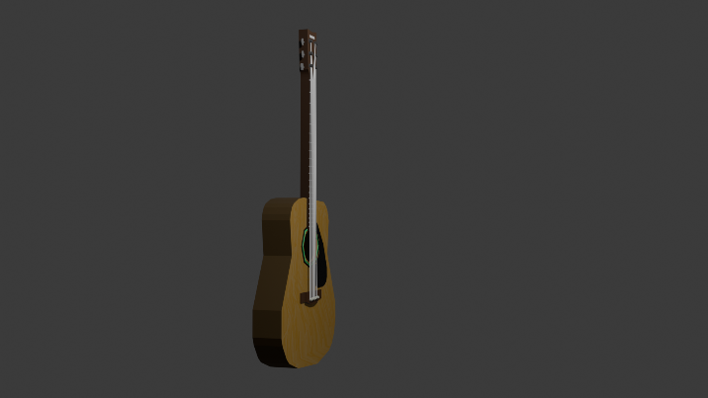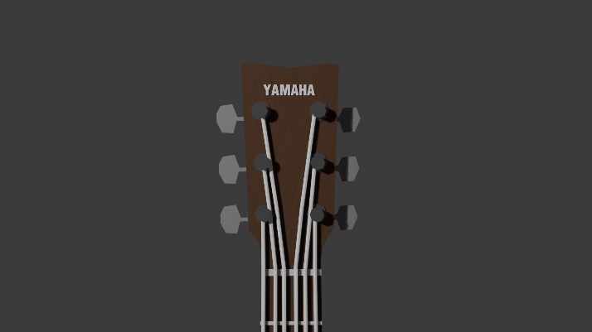

## 10/10/24 – Texture painting the scene

Today I began doing some work on the texturing for the models within the scene created by Iona. Particularly I was focused on the wood texture used on various objects aswell as the rug located in the center of the scene.

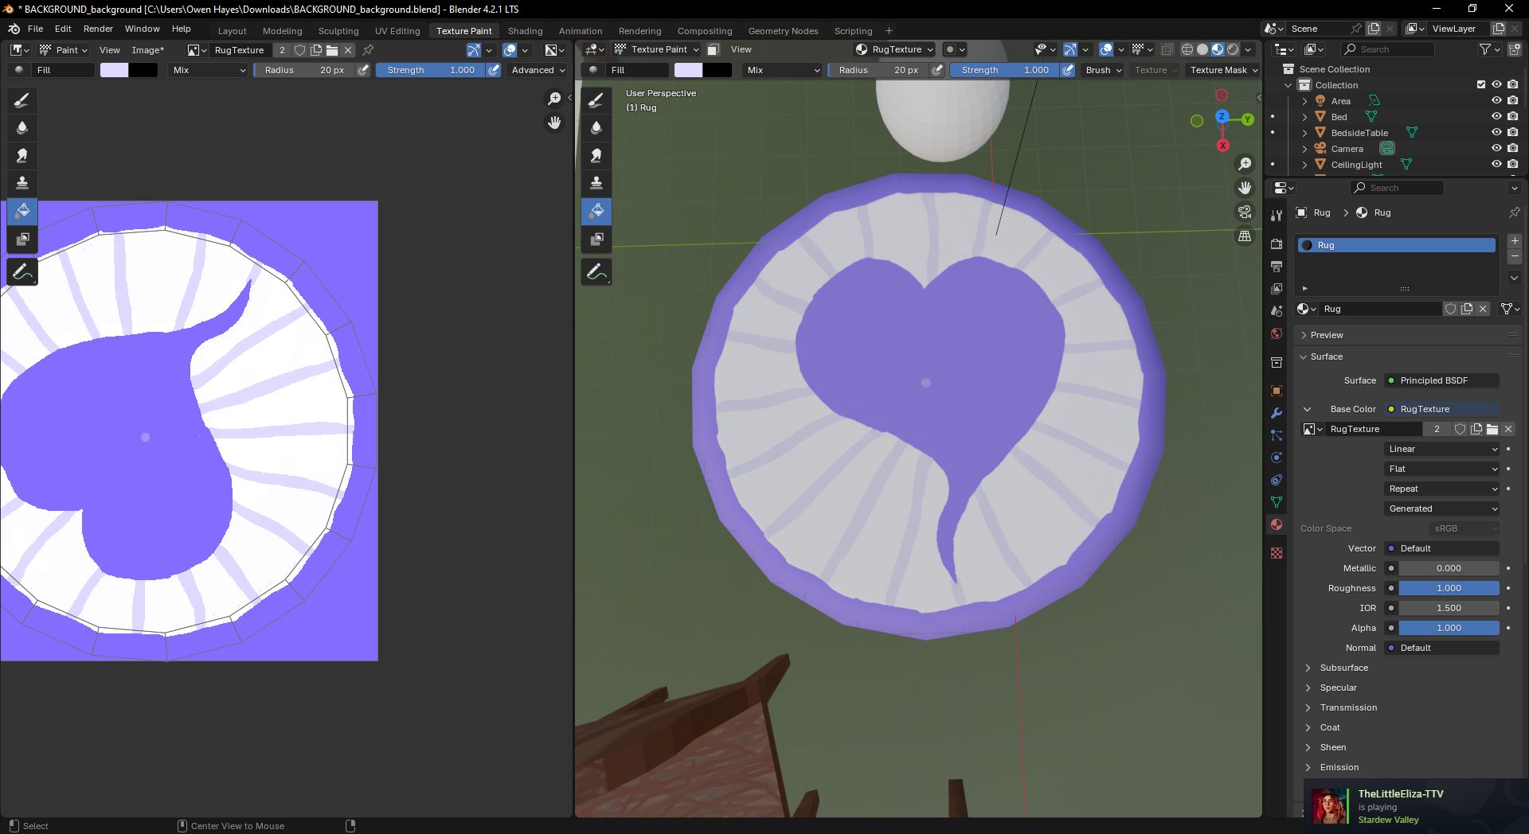

Design of the rug.

## 27/10/2024 – Continued Texture painting

I had to take some time to work on my other deadlines, which is the reason for the large gap between entries.

I was able to finish up texturing the background scene that Iona made, first I worked on the Bed:

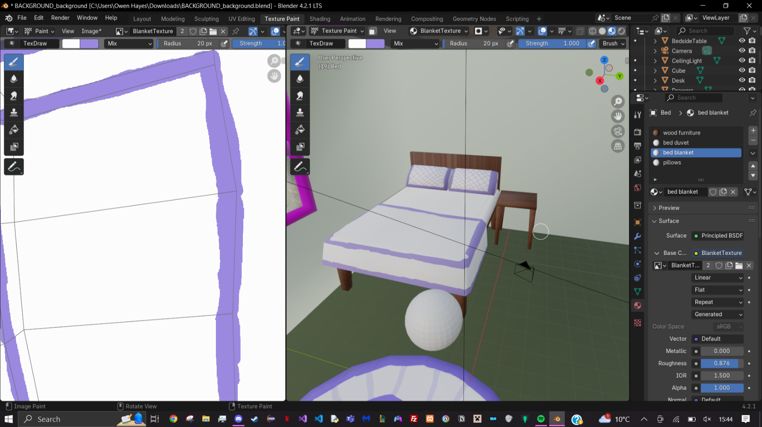

Work in progress picture of the bed. After finishing the bed I worked on the floor of the scene, going for a wooden plank look:

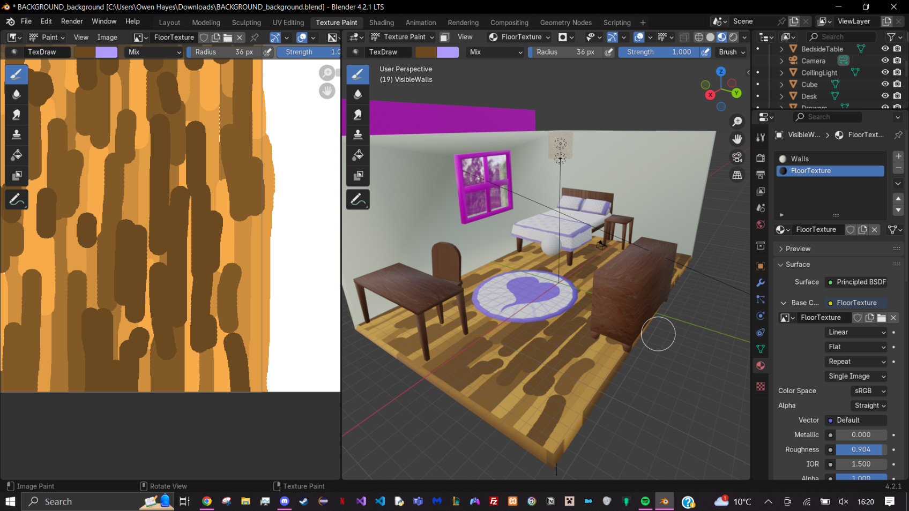

After finishing the floor, I made basic textures for the window and walls:

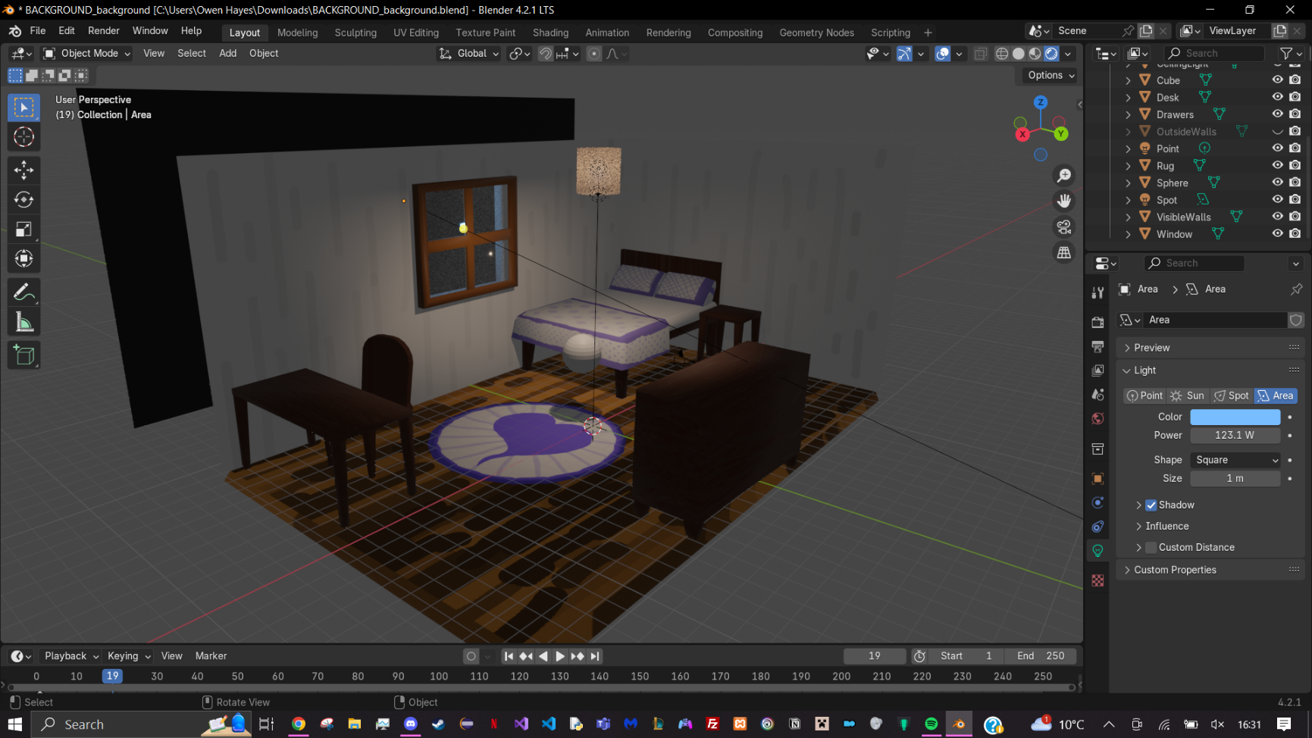

This is the model with the completed textures.

## 29/10/24 – Lighting and Final Render of Object

Today I added the guitar model into the scene for the final render image. I added in the extra fill and back lights aswell.  
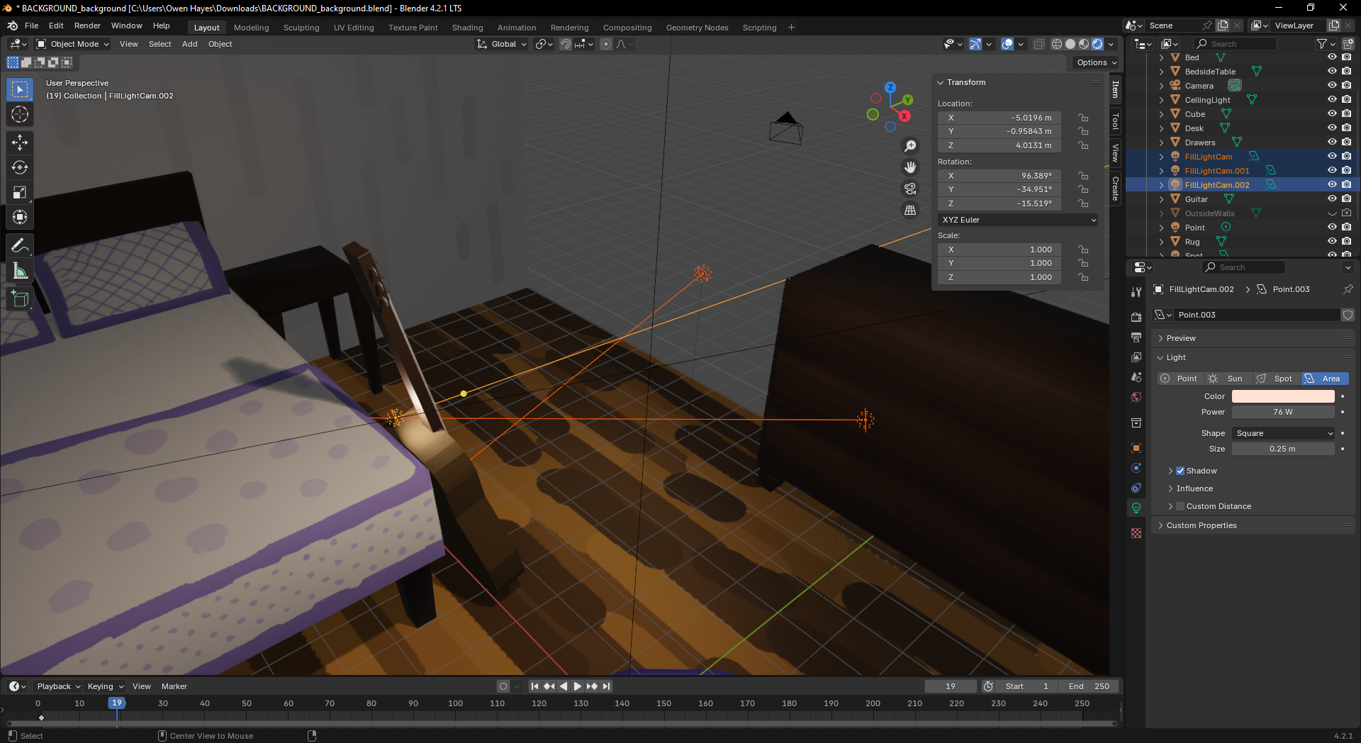

Adding in the lighting

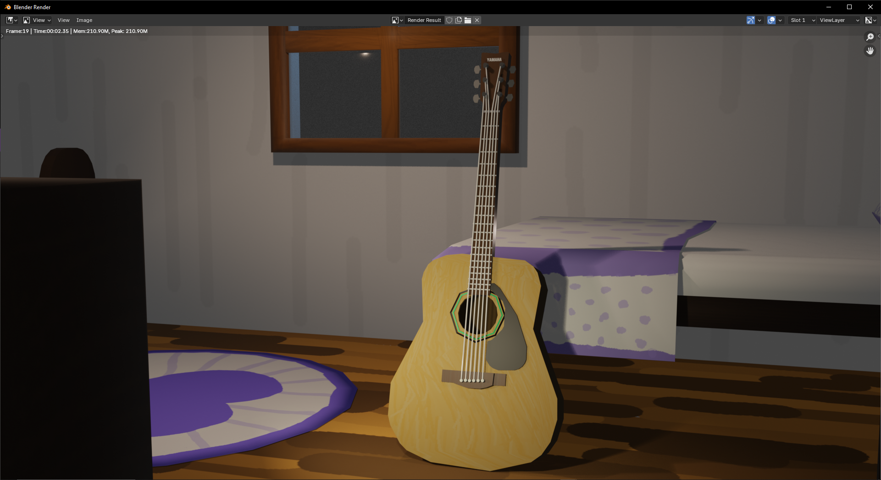

Here is the rendered image before the Depth of Field affect has been used. I want the background to be a lot less in focus than the guitar.

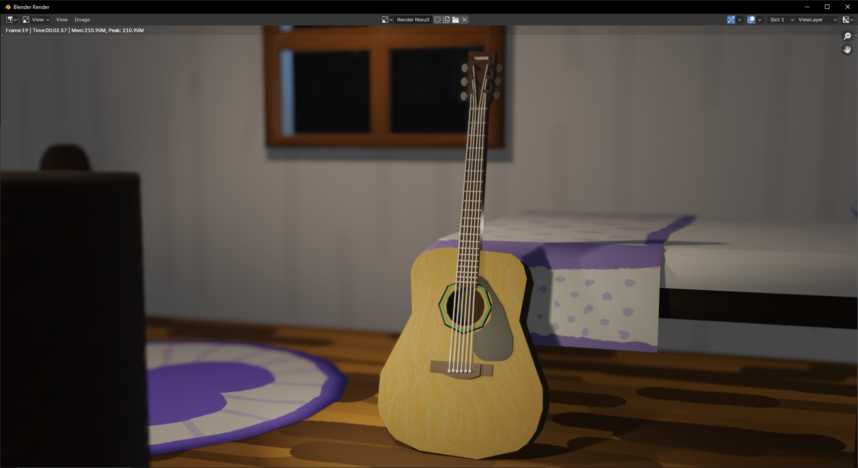

Adjusting the Fstop value of the camera in the depth of field settings I was able to get this image, I’m really happy with this!